MayPlace Hotell 179, Yulgok-ro, Jongno- gu, Seoul, Korea Tel (82)(2) 742-8080 Fax (82)(2) 742-8081
2019 PAMS Reservation Request
Main : +82-2-742-8080 / Reservation Center : +82-2-742-8052 Fax: +82-2-742-8081, E-mail: mphres@mayplace.co.kr
Thank you very much for your interest expressed in MayPlace Hotel.
Please complete this form and return directly by fax or email to the MayPlace Hotel.
Please fill in the blanks in block letter.
Reservation Details
Guest Name | First: |  | Last:
Prefix | □ Mr . □ Ms. □ Dr. □ Prof.
Affiliation (Company)
Nationality
Contact information | Phone Number:
E-mail Address
Arrival Date |  |  | Departure Date
Number of Guest
Room Type: Superior Bed Type Choice | □ Double (1 Queen) - KRW 90,000  <1 Person> with Breakfast |  | □ Twin (2 Single) - KRW 105,000 <2 Persons>  with Breakfast
□ Double (1 Queen) - KRW 105,000
<2 Persons> with Breakfast
 | *The rate is included 10% tax
Number of Rooms
* Please indicate special requests and comments :
Please guarantee your reservation.  * I hereby confirm that I understand | Cancellation | Policy below and guarantee the reservation by credit card above.
Type of Credit card | □ American Express □ Visa Card □ Master Card □ JCB Card □ Diners Club □ Other:
Credit card number | - - -
Expiry date | (Year / Month )
Card holder's Name | (Mr/Ms)
Authorized Signature of Card holder
Check-in & Check-out Policy
- Check-in from 14:00/ Check-out until 12:00
Cancellation Policy
- No cancellation charge applies prior to 10 days to arrival. Beyond that time, the 1 night will be fully charged.
- All reservations must be guaranteed with a credit card valid at the date of the start of your stay, unless otherwise specified.
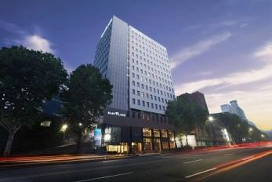

MayPlace Hotel Seoul Dongdaemun www.mayplace.co.kr

